WP2 Exemplar leads 27th Oct. 2015, 13-17h

Consortium Meeting 5
28th-30th October 2015
Aix-en-Provence, France

Led by: Kim Nicholas, Heather Schoonover
Session topic: Stakeholder engagement, Presentation and discussion of Heathers paper outline and questionnaires to the Exemplars

Developments & Progress
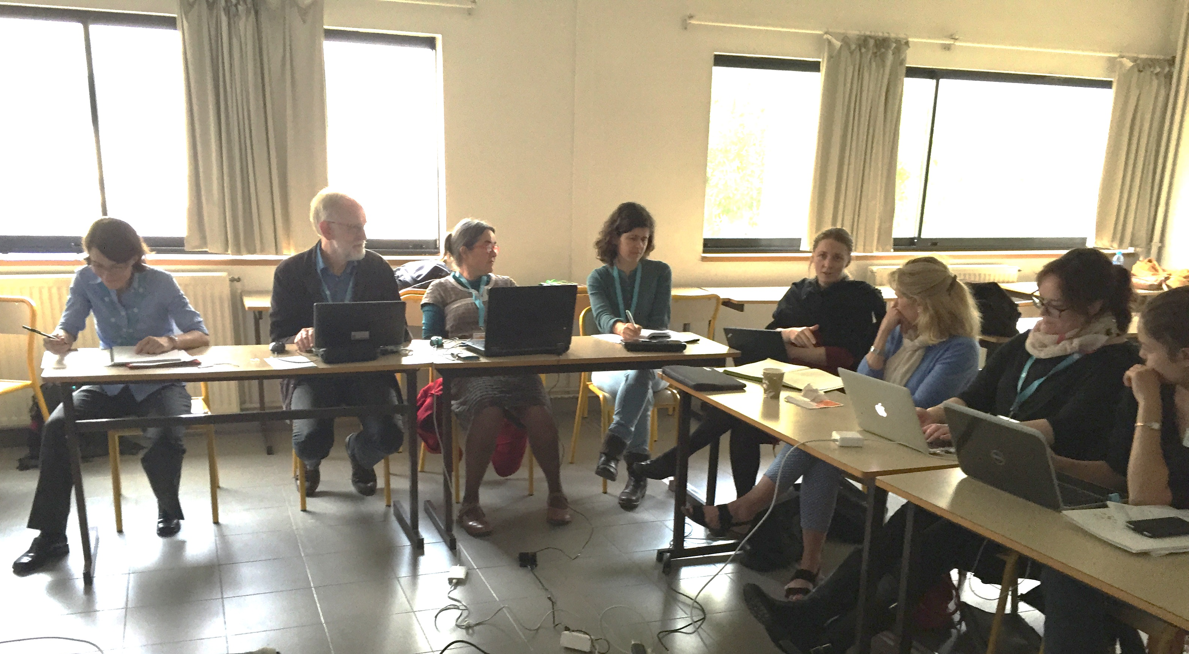
Heather and Kim presented the outline of a paper on stakeholder engagement with the aim to synthetize experiences, key pieces of stakeholder involvement and best practices regarding the operationalization of ES throughout the 12 exemplars. Therefore several questions prepared by Heather and Kim were discussed in the form of a focus group (in preparation of a questionnaire being handed out to all exemplars later): 1. Why stakeholder involvement, 2. Stakeholder identification 3. Timing of stakeholder involvement, 4. Status of relationships, 5. Stakeholder interactions / potential conflicts through stakeholder mix, questions from the discussion section of the paper such as What about stakeholder engagement is unique in ES?

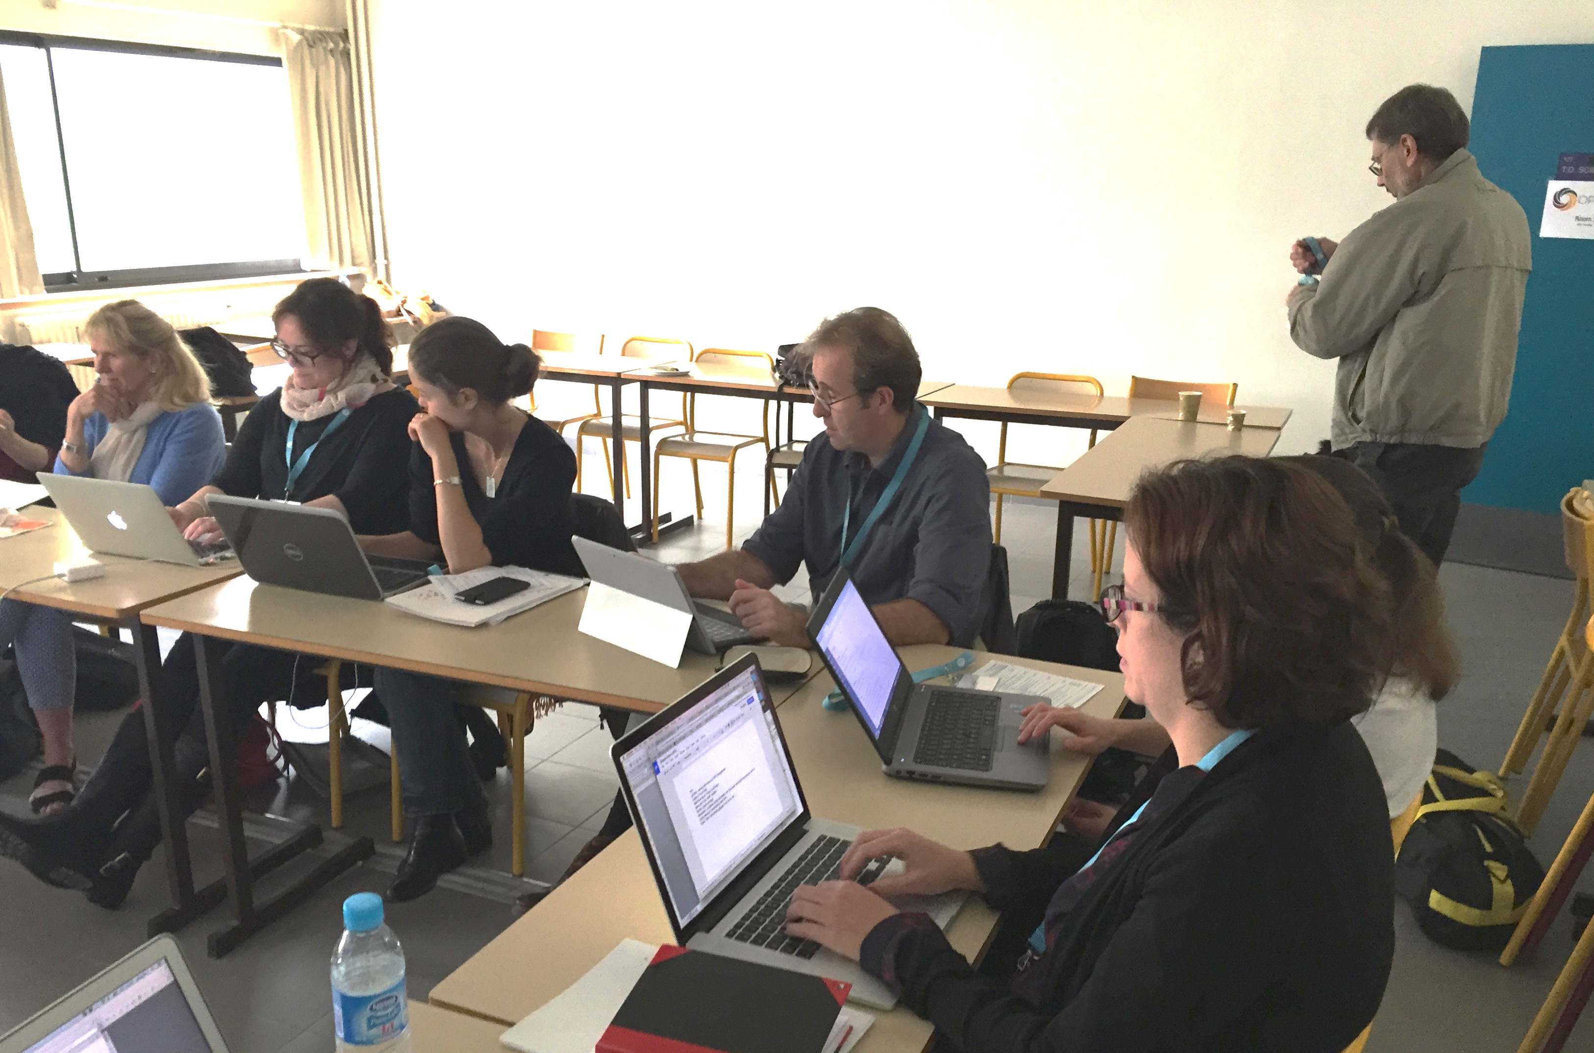
Group and discussion points
- Role of the researcher, are researchers also stakeholders and to what extent do they influence /shape the process; request to decide upon the role or make this role explicit, many experiences were brought up explaining that education from the researches to the stakeholder community was essential.
- Way of stakeholder involvements such as whether to start with a structured process or leave the decisions and the process design up to the stakeholders (co-design), group reflection on experiences from exemplars revealed pros and cons.
- General discussions on the scope and frame of the paper

Going forward
Heather has handed out a questionnaire to all exemplars and assembled interested participants for writing the paper, (which leads to milestone (MS2.14) in January 2016). some of the attendees of the meeting already signed up for specific sections
If other people are interested in contributing they can sign up for a section with Heather.

